**DAILY ONLINE ACTIVITIES SUMMARY**

|  |  |  |  |  |  |  |  |
| --- | --- | --- | --- | --- | --- | --- | --- |
| **Date:** | **01-06-2020** | | | | **Name:** | **Harshitha M** | |
| **Sem & Sec** | **8th 'A'** | | | | **USN:** | **4AL16CS038** | |
| **Online Test Summary** | | | | | | | |
| **Subject** | | **SMS** | | | | | |
| **Max. Marks** | | **60** | | **Score** | | **60** | |
| **Certification Course Summary** | | | | | | | |
| **Course** | **Python for machine learning** | | | | | | |
| **Certificate Provider** | | | **Great learning** | **Duration** | | | **3hr** |
| **Coding Challenges** | | | | | | | |
| **Problem Statement:C prog to print the no in this series**  **1**  **1 2 1**  **1 2 3 2 1** | | | | | | | |
| **Status:Solved** | | | | | | | |
| **Uploaded the report in Github** | | | | **Yes** | | | |
| **If yes Repository name** | | | | **Harshitha-M** | | | |
| **Uploaded the report in slack** | | | | **Yes** | | | |

Online Test Details: (Attach the snapshot and briefly write the report for the same)

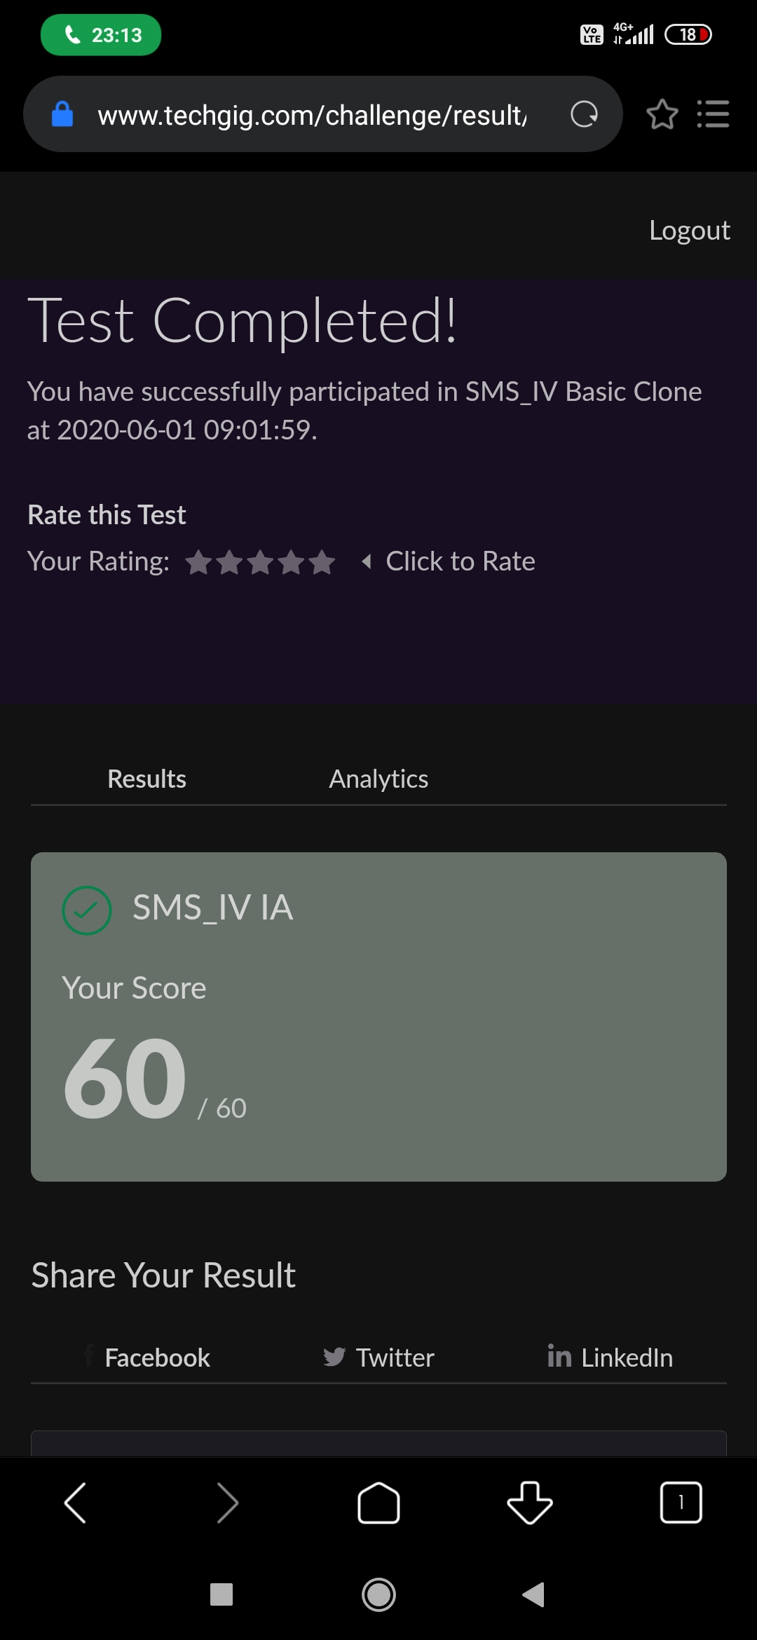

Certification Course Details: (Attach the snapshot and briefly write the report for the same)

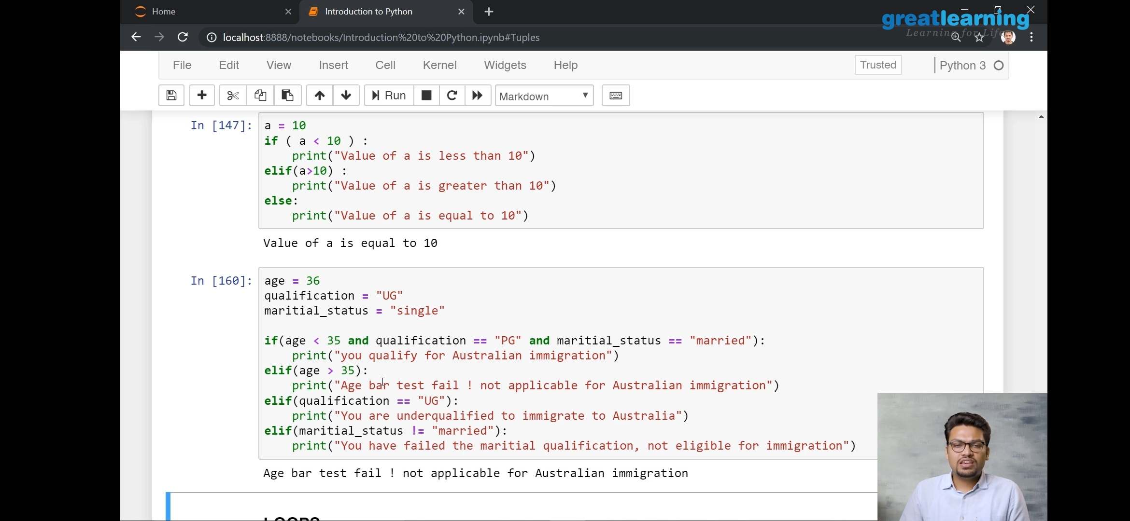

Coding Challenges Details: (Attach the snapshot and briefly write the report for the same)

solution

#include<conio.h>

#include<stdio.h>

void main()

{

int i,j,k,before=0,array[10][10];

clrscr();

for(i=1;i<=5;i++)

for(j=1;j<=(2*i);j++)

{

if(j<=i)

{

array[i][j]=before+1;

before++;

}

else

{

array[i][j]=before-1;

before--;

}

}

before=0;

}

for(i=1;i<=5;i++)

{

for(j=1;j<=((2*i)-1);j++)

{

printf("%d",array[i][j]);

printf("\t");

}

printf("\n");

}

getch();

}